Trans kit pieces: Tubing:
2 cm
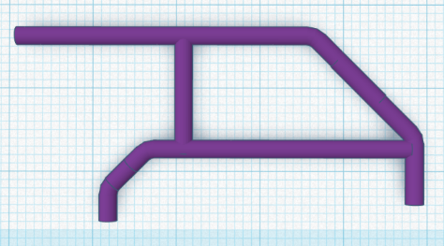
- Base Plate
- Body
- 4 Wheels [Rim + Tire]
- 2 Engine vents [L + R]
- 2 Seat-Assy-parts
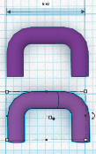
- 1 Front Bumper
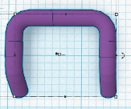
- 1 Rear Bumper
- 1 Dashboard
- 1 Steering wheel
- 1 Shifter stick
- 2 Axes
Suggested base options [not included]:
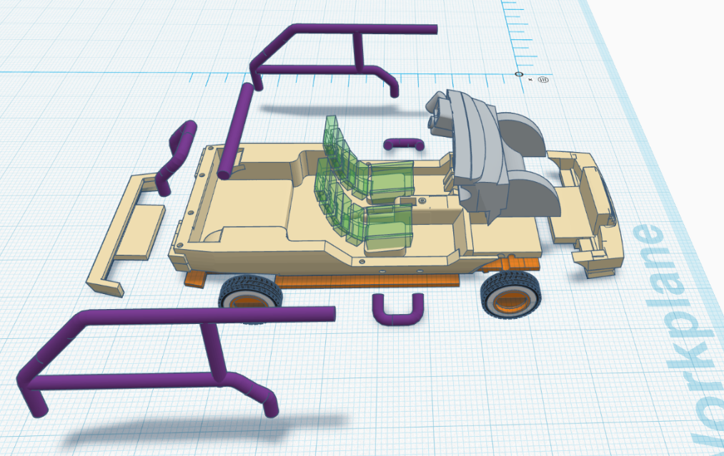
- Dinky Toys Visa
- Norev Visa
- Solido Visa

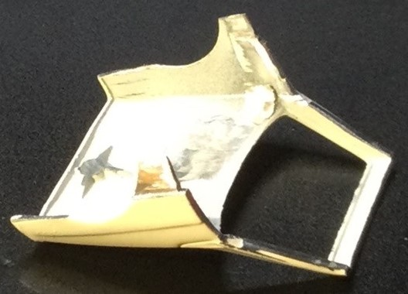
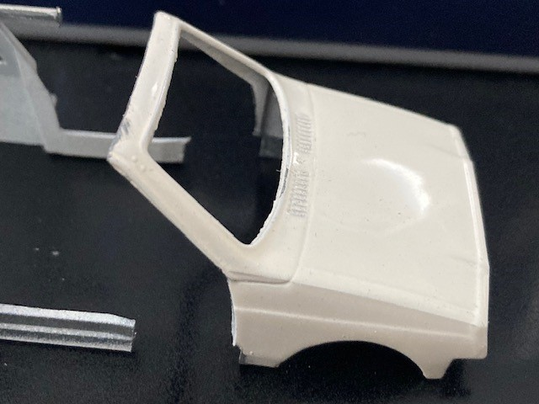
Cutting of the base model: Used Visa-part of donor:

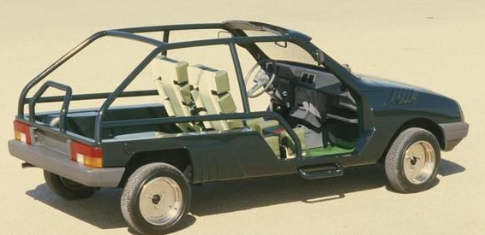
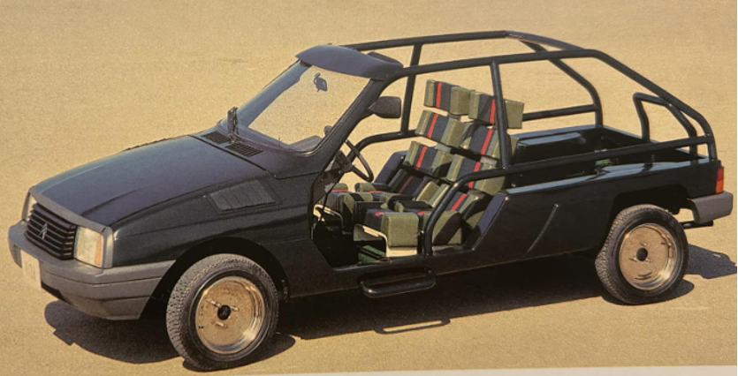
Variants:
